Name ________________________________________ Period ___________ Date_______________
Module 1 Quiz 2 (1.2-1.5)
Use the pattern below to answer questions 1-7.
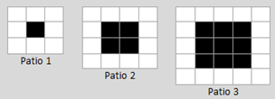
- Describe the pattern you see over time with the total number of white tiles.

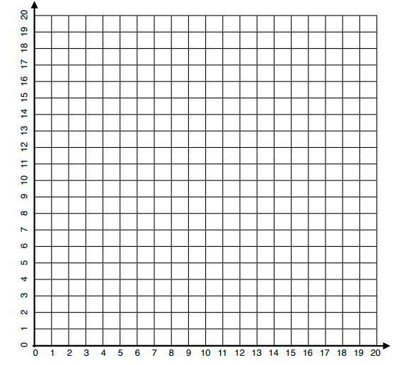
2) Fill in the table below. 3)Graph the first two columns below. Label your axes.
Patio Number | Total # of White Tiles

4) Write a recursive equations to model the pattern.

5) Write an explicit equation for the pattern above. Make sure it is in function notation.

6) Evaluate f(25) using your explicit equation for the number of white tiles. Show your calculations.

7) Is the sequence above arithmetic or geometric? Why?

8. Which of the following is not an arithmetic sequence?
A. 37, 31, 25, 19, …
B. -1, -3, -5, -7, …
C. 13, 4, -6, -17, …
D. 5, 8, 11, 14, …

Write a recursive formula for the sequence 6, 9, 12, 15… Then find the next term.
A f(n) = f(n – 1) + 3, where f(1) = 3; 18
B f(n) = f(n – 1) + 3, where f(1) = 6; 18
C f(n) = f(n – 1) − 3, where f(1) = 3; 18
D f(n) = f(n – 1) * 3, where f(1) = 6; 18

The table shows the predicted growth of a particular bacteria after various numbers of hours. Write an explicit formula for the sequence of the number of bacteria.
Hours(n) | 1 | 2 | 3 | 4 | 5
Number of Bacteria | 11 | 28 | 45 | 62 | 79

A f(n) = 17n + 11
B f(n) = 17n - 6
C f(n) = 11n
D f(n) = 17n

A large asteroid crashed into a moon of a planet, causing several boulders from the moon to be propelled into space toward the planet. Astronomers were able to measure the speed of one of the projectiles. The distance (in feet) that the projectile traveled each second, starting with the first second, was given by the arithmetic sequence 13, 26, 39, 52 . . . . Find the total distance that the projectile traveled in 9 seconds.
A 91 feet
B 104 feet
C 117 feet
D 130 feet

A recursive formula for a sequence is f(n) = f(n-1) + 7, where f(1) = 10. Find the explicit formula, then find f(11) .
A f(n) = 7n + 10; 87
B f(n) = 7n -7; 70
C f(n) = 7n + 3; 80
D f(n) = 7n + 7; 84

