Unit 1- Quiz 1: Transformations

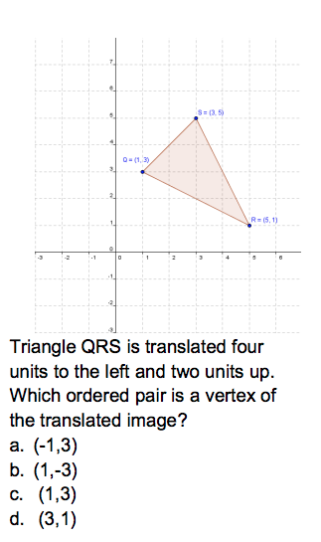

Name: _____________________________________________

Period: _______________

