Unit 1: Transformation & Congruence Study Guide
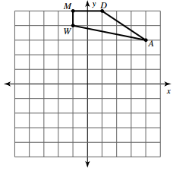
1) Reflect Quadrilateral MDAW over the x-axis.
Plot and list the coordinates:
M (-1, 5) → M’ ____________
D (1, 5) → D’ ____________
A (4, 3) → A’ ____________
W (-1, 4) → W’ ____________
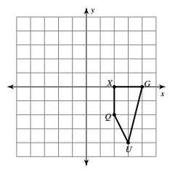
2) Translate Quadrilateral XGUQ left 4 units and up 3 units.
Plot and list the coordinates:
X (2, 0) → X’ ____________
G (4, 0) → G’ ____________
U (3, -4) → U’ ____________
Q (2, -2) → Q’ ____________

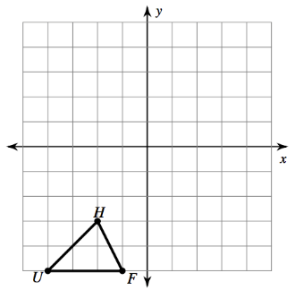
3) Rotation Triangle UHF around the origin 270° clockwise.
Plot and list the coordinates:
U (-4, -5) → U’ ____________
H (-2, -3) → H’ ____________
F (-1, -5) → F’ ____________

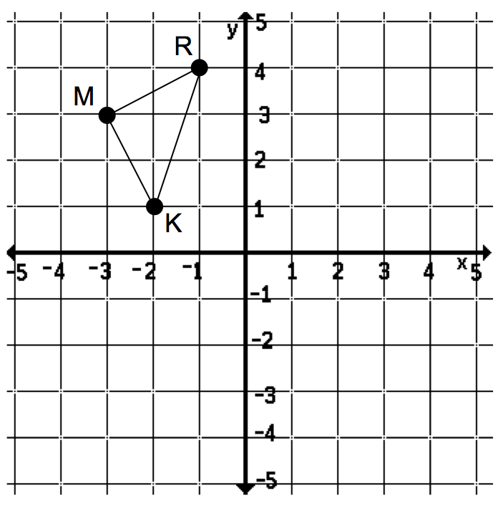
4) A single transformation is applied to Triangle KMR, resulting
In the point K’.
a) Describe the transformation if a translation was
used to create point K’.
K’

b) Describe the transformation if a rotation was
used to create point K’.

c) Could a reflection be used to create the point K’? Explain.
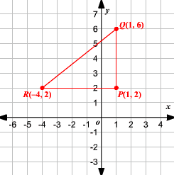
5) Triangle PQR is shown on the coordinate plane.
Triangle PQR is reflected over the x- axis to form the image triangle P’Q’R’ (not shown). Then triangle P’Q’R’ is translated 4 units left to form triangle P’’Q’’R’’ (not shown).
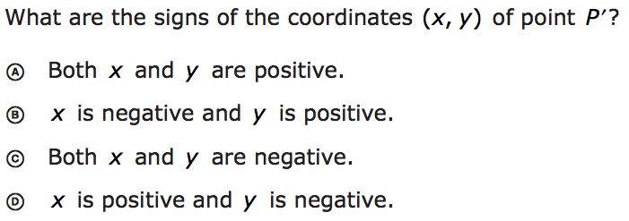
a)

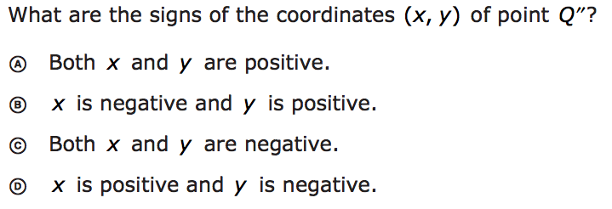
b)

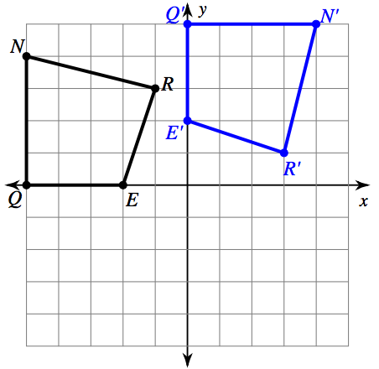
6) Quadrilateral NREQ was rotated using the origin as the center of
rotation, resulting in Quadrilateral N’R’E’Q’. Which of the following
could describe how many degrees the figure was rotated?

a) 90° Counter Clockwise d) 90° Clockwise
b) 180° Counter Clockwise e) 270° Clockwise
c) 270° Counter Clockwise f) 180° Clockwise

7) What will be the new coordinate of point A, after quadrilateral ABCD is reflected over the y-axis and then translated 2 left and 5 down?
8) A triangle has vertices at L (-4,1), M (-2, 4), & K (-2,1). Plot triangle LMK and then rotate it 90° counter clockwise. Then list the vertices for L’M’K’.
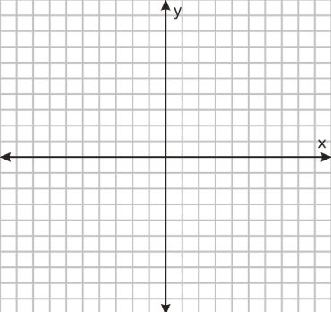
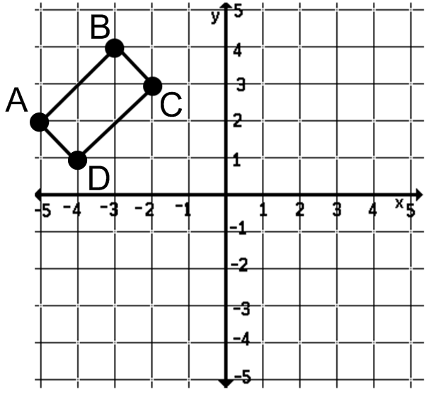

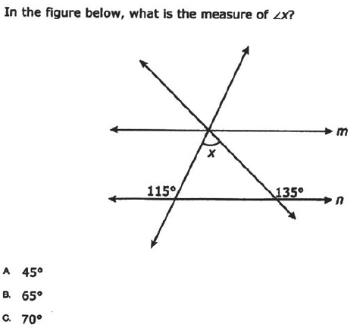
9)

10) Parallel Lines m and n are cut by Transversal t as shown.
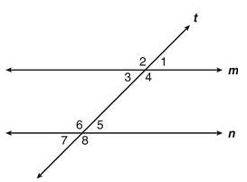
State whether or not the statements are true or false.
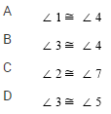
11) Given $l∥m$ and lines s and t are transversals. If $m∠2=45°$ and $m∠3=55°$, find $m∠13$.
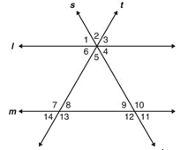

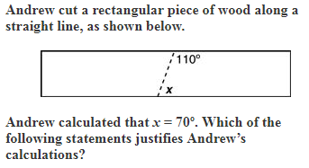
12)

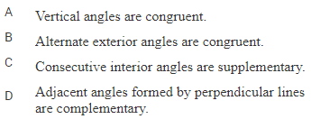

13) The measure of $∠COB$ is 125°. What is the measure of $∠AOD$?
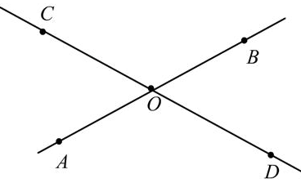

14) Lines x and y are parallel and cut by a transversal
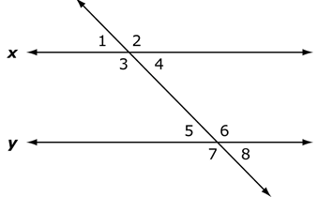
List a pair of angles that are alternate exterior angles.
List a pair of angles that are alternate interior angles.
List a pair of angles that are vertical angles.
List a pair of angles that are corresponding angles.
List a pair of angles that are same side interiors angles.
If $∠1≅37°$, find the rest of the angles’ measurements.

